**Lesson 15 Academic Presentation II**

**Lesson Objectives:**

1. Learn how to create proper presentation slides
2. Recognize the differences between good slides and abused slides
3. Learn the language used to describe slides
4. Get to know the questions for different purposes
5. Learn how to raise and handle questions
6. Learn some useful expressions used for raising and handling questions
7. Language Focus: Transitions

**Part One Creating presentation slides**

**1. Useful expressions of describing slides**

**1) Referring to Slides:**

* As you can see here …
* Here we can see …
* Let me show you …
* Let’s have a look at …
* I’d like you to look at this …
* I’d like to draw your attention to …
* If you look at this slide, you can see …
* This slide shows …

1. **Giving examples:** 
   * Let me give you an example.
   * I’d like to give you some examples.
   * A good example of …is …
   * To illustrate this point …
   * To support what I’ve said …
   * Imagine that you …
   * There are many ways to do this, for example…
   * There are many examples of this, such as …
2. **Giving explanations** 
   * The main explanation for this is …
   * There are two reasons for this. First, …Second, …
   * This can be explained by two factors. Firstly, …Secondly, …
   * This is due to …
   * As a result of …
   * Due to the fact that …
   * Thanks to …
   * One reason for this is …another reason is …
   * The problem goes back to …
3. **Introducing the data** 
   * This graph/chart/table shows/illustrates that …
   * According to the figures/statistics …
   * We can see from …
   * As is shown in the …
   * On the x/horizontal axis we have …
   * The vertical/horizontal axis represents/displays …
4. **Explaining positions** 
   * On the left/right
   * On the left side/right side
   * In the middle/center
   * At the top/bottom
   * The upper/lower part/half/section
   * Close to/near the top right corner
5. **Steps for presenting data**

Step 1. Introduction:

*the title of the graph/chart, the variables, the meanings of symbols and colors*

Step 2. Body:

*a detailed description of the data*

Step 3. Conclusion:

*a summary of the pattern*

**Part Two Raising and handling questions**

**1. Four Steps of Raising a Question**

|  |  |
| --- | --- |
| *I have a question for Prof. Lee.*  *Prof Lee, your speech has deeply impressed me, especially the application of the new experimental method in your field.*  *My question is whether the new method has some weak points as compared with the old one?*  (after the answer)  *Yes, I got it. Thank you very much for your answer.* | 1. Signaling you want to ask a question 2. Expressing your appreciation 3. Asking a specific question 4. Giving your feedback |

**2. Six Steps of Answering a Question**

|  |  |
| --- | --- |
| If some listeners raise their hands to ask questions.  If questions are written on a slip of paper.  Question: …  *Sorry, I didn’t catch it clearly. Could you please say that again?*  *Sorry, I’m not quite sure of your question. Could I understand your question like this: …?*  *That’s an interesting question.*  (Question: *In your experiment, which is the most important factor, the temperature, the humidity, or any other factors?*)  Repetition: *This lady would like to know which is the most important factor in my experiment, the temperature, the humidity, or any other factors.*  *It is hard to say which one is more important, because all these factors are closely interrelated and a slight change in one factor will cause a huge difference in the result.*  *I don’t know whether this answered your question or not.* | 1. Choosing a questioner 2. Listening carefully to the question 3. Welcoming the question 4. Repeating the question 5. Answering concisely 6. Asking the questioner for feedback |

**3. Useful Expressions for Q & A**

**Raising a question**

**1) Signaling you want to ask a question**

* I’d like to ask Prof. Lee a question. / I have a question for Dr. Lee.
* Could I ask you a question, Prof. Lee?

**2) Expressing your appreciation**

* Dr. Lee, thank you very much for your insightful talk.
* Dr. Lee, your speech has deeply impressed me, especially … / I appreciate your point about …
* Dr. Lee, you did splendid work!

**3) Clarifying doubts**

* Mr. Smith, what do you refer to by getting a peak value?
* I don’t quite understand what you really mean by saying “…”. Can you explain it again?
* Is it possible for you to show me again your last slide?

**4) Asking for additional information**

* You mentioned very briefly that … Would you please elaborate on that point?
* I’m very interested in … Could you tell me exactly how … ? / Would you please say a few more words about …，particularly …

**5) Expressing different opinions**

* If I am not mistaken, you said in your presentation that … However, as far as I know, … Would you please give us some explanation about this?
* Perhaps we’re looking at the problem from different viewpoints/ angles/ approaches. To the best of my knowledge, what you say seems to be theoretically unclear in … For example, … Could you give us further explanation on that aspect?

**6) Giving your feedback**

* Thank you very much for your answer. / Yes, I got it. Thank you.

**Handling a question**

**1) Asking for repetition**

* I am sorry I couldn’t hear you. Would you please say that once again?
* Pardon, could you repeat your question?
* Sorry, I didn’t catch it clearly. Could you please say that again?
* I am sorry, I am not a native English speaker. Could you speak a little more slowly please? Thank you. / I don’t quite understand your question. Would you be more specific?

**2) Repeating/Rephrasing a question**

* Do you mean …? / If I understand you correctly, what you are asking is …?
* You were asking me about … Am I right?
* Sorry, I’m not quite sure of your question. Could I understand your question like this? …
* Could I understand your question this way? …
* It seems to me that what I have been asked perhaps means … Was that your question?

**3) Welcoming a question**

* This is a good/interesting question.
* Thank you very much for your good comments and suggestions.
* I appreciate your encouragement for my future study.
* Thank you for bringing up these questions. They are meaningful but challenging questions…

**4) Asking a questioner for feedback**

* I don’t know whether this answered your question or not.
* Did I answer your question? / I hope I have answered your question.

**5) Indicating limited time**

* We are running out of time. Therefore, I will focus only on your first question.
* Because the time is limited, I am afraid I cannot answer the rest of your questions. / I will answer it later if time permits.

**Handling a non-ordinary question**

1. **Avoid answering the question**

* Sorry, I am afraid I know very little about the matter. So I don’t think I can answer your question right now.
* I’m sorry. I don’t happen to know the answer to that question, but I’ll be happy to check into it for you.
* I wish I could answer your question, but unfortunately I have no good answer now / I don’t have the information on hand.

1. **Answer the question partially**

* For the time being, I would like to answer your question of …
* One of the questions you put forward is about …, which, I think, is very interesting. And now I’d like to answer it with the following example.
* All right, I’ll now say a few words about my future consideration on the subject … And I think that might be the answer to your last question.

1. **Answer the question later**

* If it is convenient to you, I would like to talk it over with you after the session or at any other time.
* Please let me have your contact information after the meeting and I’ll get back to you with it soon.
* Would you mind emailing me that question, and
* Sorry, I really need to check with a colleague before being able to answer that question.
* We are now doing an experiment on this problem and, if you agree, I’ll answer your question when it is completed.

1. **Shift the attention**

* Mr. Chairman, just now a gentleman in the back row asked me a question, but I didn’t quite understand what it was. Could you explain it to me?
* My team member, Dr. Lee, has worked on it for five years/is an expert in this field, and he may be more suitable to provide you with detailed information/ he would be a better person to answer your question.
* Mr. Lee and I work in the same laboratory, so I would leave that question to Mr. Lee. I’m sure he will certainly give you a satisfactory answer.
* If you are really interested in the subject, I suggest you take a look at the 3rd chapter of my book entitled …
* I’m sorry, but I’m not sure on that point. Is there anyone here who can help to answer?
* I’m very interested in your question. Therefore, I would like to know how you have initiated the research project.
* …what about your experiment result?

1. **Change the topic**

* That’s an important question — almost as important as … (another question you could answer)
* I was hoping someone would ask me that question, because it gives me an opportunity to talk about … (something you are familiar with)
* I think we need to look at the problem from a different angle … (the angle you could handle)

1. **Always be polite**
2. **To disagreement**

* I’m afraid that our different views on the topic may come from the different angles from which we’re looking at the problem. My idea is mainly out of the theoretical consideration, specifically, on the basis of the following three aspects: …
* Well, it seems that your understanding of my viewpoints is somewhat different from my original intention. That might be due to the short time that I couldn’t put it clearly. Here I’d like to explain it briefly. My original intention is …

1. **To strong disagreement**

* Well, I guess we’ll have to agree to disagree on this point.
* Unfortunately, there’s no time to go into this more deeply right now.

1. **To questions pointing out your mistakes**

* I believe that my information is correct, but I will certainly recheck my facts.
* I appreciate your bringing this to my attention. I will have to recheck my source to see what is correct.

1. **To show-off questions**

* You are absolutely right. I didn’t mention that point because it is quite technical / because there was no time. But it is covered in my paper.

1. **To aggressive questions**

* I think you have raised an interesting point and it would be great if we could discuss it in the bar.
* I was not aware of those findings. Perhaps you could tell me about them during the coffee break.
* However, as it has no direct relation with our subject, could we discuss it after the conference?

**Exercise**

1**. Presenting data exercises.**

**Ask students to present the following data:**

A.

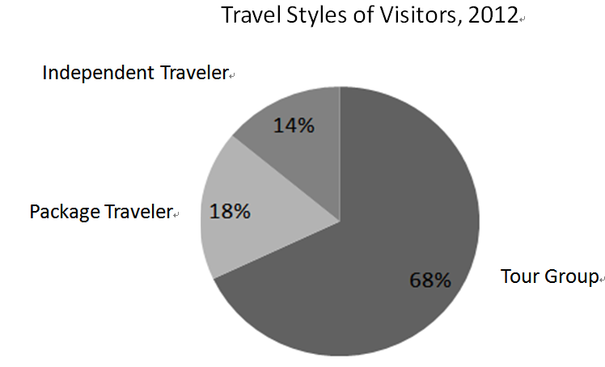

**B.**

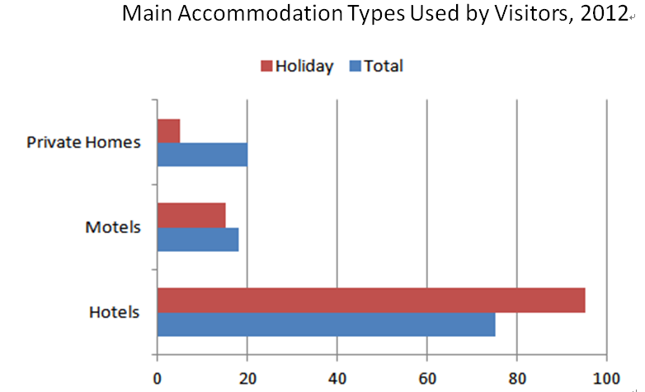

**2. Question and Answer: Watch the video “Presentation Skills”(from minute 0 to 6 ), and try to raise some questions to the lecturer.**

**3. Language Focus: Transitions**

Prepare a one-minute presentation in which you describe an incident in neutral or “objective” language. Then describe the same incident in language that makes the same incident sound negative. Finally, use language to make the incident sound favorable. In each description use the same details, change only your language. Which presentation do you think would have been most persuasive to the audience?